Multi-Threaded Quiz System

1. Algorithm Explanation
This system simulates a synchronized classroom environment using POSIX threads, Mutexes, and Semaphores.

Concurrency Control Mechanisms
• Mutex (g_lock): Protects RAM (g_board, g_totalScore). Prevents race conditions during live UI updates and math calculations.
• Binary Semaphore (g_fileSem): Protects the Hard Drive (quiz_results.txt). Ensures that student logs are written sequentially without overlapping text.
• Counting Semaphore (g_computerSem): Crowd control. Limits the number of students taking the quiz at once to simulate limited hardware availability.

2. Stress Testing & Comparative Analysis
To understand the limits of the multi-threaded system, we analyze two specific stress-test scenarios.

Scenario A: Scaling Student Threads (N = 100+)
In this test case, we increase the number of student threads significantly (e.g., from 15 to 100+).
- Findings:
- Thread Contention: As student numbers rise, more threads will be stuck in the 'Waiting... 🕒' state because the Counting Semaphore (g_computerSem) only allows 3 at a time.
- Context Switching Overhead: The CPU spends more time swapping between the 100+ threads. You might notice a slight lag in the Monitor Thread's refresh rate.
- Queueing Effect: The simulation becomes 'Batch-like.' Students finish in groups of 3, and the total execution time increases linearly with the number of students.

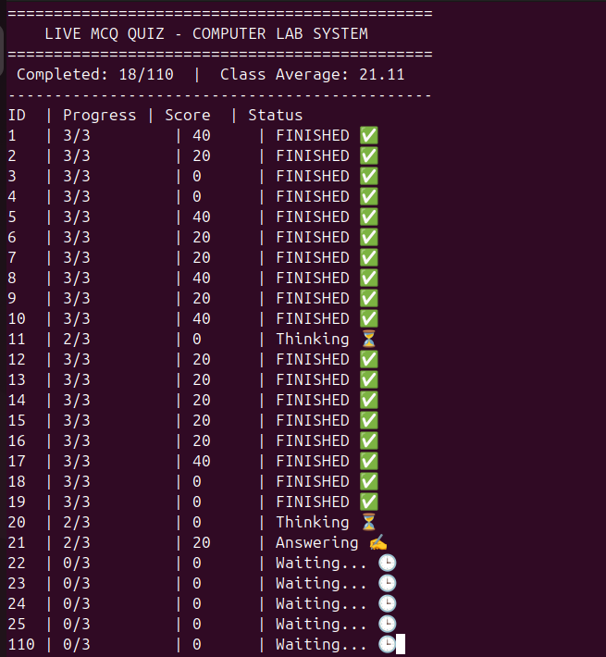

Scenario B: Scaling Question Count (Q = 50+)
In this test case, we keep the student count low but increase the number of questions per student significantly.
- Findings:
- Resource Bottleneck: Since each student occupies a computer for a much longer time, the waiting students remain in the queue for extended periods. The 'turnover rate' of the lab drops.
- Log File Size: The 'quiz_results.txt' file grows very fast. The file semaphore (g_fileSem) becomes the most hit resource, as students frequently request access to write their many answers.
- Statistical Stabilization: With more questions, the Class Average becomes more stable and less prone to random luck, following the Law of Large Numbers.

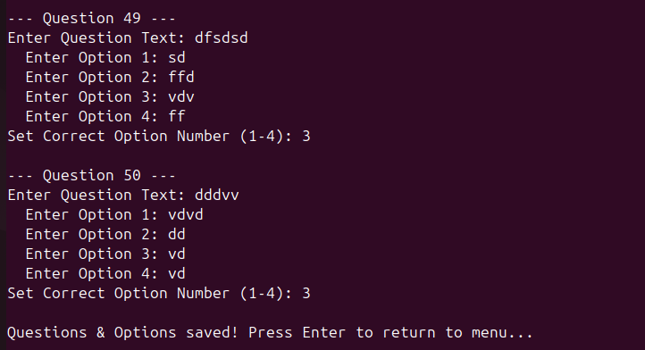

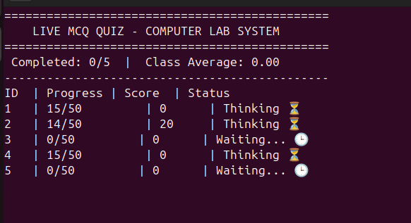

3. Summary of Findings
Metric | Increase Students (100+) | Increase Questions (50+)
Primary Bottleneck | Memory / Thread Management | I/O (File Writing) & Lab Seats
Visual Behavior | Huge list of "Waiting" students | Slow progress on the "X/50" bar

4. Conclusion
Increasing students tests the system's ability to handle concurrency and queueing, while increasing questions tests the system's throughput and resource holding time.
